DIP Project Report



“Image Enhancement using Histogram Equilization”

Under the Guidance of

**<Dr. Khushboo>**

**Submitted By:**

**Anshuman Kumar Singh, 04117711722, IIOT**

**Ritesh Kumar Sarkar, 60517711723, IIOT**

**Sunny Kumar, 60317711723, IIOT**

**DECLARATION**

This is to certify that DIP Project Report titled “Image Enhancement Using Histogram Equalization”, for the DIP Project with AIML/IOT-352 is submitted by Anshuman Kumar Singh (04117711722) Ritesh Kumar Sarkar (60517711723) Sunny Kumar (60317711723) is comprises of our original work. The due affirmation has been made within the report for utilizing the referenced work.

**Date:25/04/2025 Signature <Anshuman, 04117711722>**

**Signature <Ritesh, 60517711723>**

**Signature <Sunny, 60317711723>**

# Acknowledgment

We would like to express my heartfelt gratitude to all those who have contributed to the successful completion of our DIP project report. First and foremost, we would like to extend our deepest appreciation to our supervisor, [Supervisor's Name], for their constant guidance, valuable insights, and unwavering support throughout this journey. We are also indebted to the staff and faculty members of VIPS-TC, GGSIPU, Dwarka, Delhi, whose expertise and cooperation were instrumental in enhancing our learning experience. Additionally, we are grateful to our fellow students who provided us with invaluable feedback and encouragement.

(Signature of the students)

# Table of Contents

Keywords

Chapter 1: Introduction and Motivation…………………………..…………………….. Chapter 2: Literature Review (Related Work)…………………………………………. Chapter 3: Research Methodology …………………… ……………………………….

* 1. : Working Principle
  2. : Image processing Tool Box
  3. : IMAGE EVALUATION SETS AND DATABASES

Chapter 4: Results and Discussion………………………………………….

* 1. : Use Case Diagrams, Flow Chart/ Activity Diagram…………………
  2. : Connection Diagram (In case of Hardware Project)…………………

4.4: Description of Hardware Components used………………………… Chapter 5: Proposed Work and Methodology Adopted……………………………. Chapter 6: Results and Discussion…………………………………………………. Chapter 7: Conclusion……………………………………………………………… Chapter 8: Future Scope of Work…………………………………………………… REFERENCES

## Abstract

Histogram equalization is a widely used technique in digital image processing that enhances the contrast of images by effectively spreading out the most frequent intensity values. This report explores the theory, methodologies, and implementation of histogram equalization for image enhancement purposes. We analyze existing literature, describe the tools and datasets used, and detail the methodological steps taken to develop and test the proposed solution. Results demonstrate improved image quality, supporting the efficacy of histogram equalization in applications such as medical imaging, remote sensing, and surveillance.

## Introduction and Motivation

Enhancing images is a large component of digital image processing. Essentially, it's just taking various methods to make images more intelligible or useful—whether that's so humans can better understand them or computers can more easily analyze them. That comes into play particularly when the images themselves aren't very good to start with— such as ones shot in dim light or where crucial details are obscured by noise or low contrast. One of the most widely used and successful methods for improving an image is referred to as histogram equalization. It's used so much because it's easy and it's effective. Essentially, this process normalizes the brightness levels throughout an image so that contrast improves. It does this by distributing the pixel brightness values across the full range—brightening dark spots, and avoiding bright spots from being overly intense. This allows for details to be visible that would otherwise remain concealed. Histogram equalization truly comes into its own when you're working with low-contrast images. For instance, it can be used to make land contours stand out in satellite imagery, or emphasize faint details in medical scans such as X-rays or MRIs—details that might be vital to a diagnosis. It's also really handy in security cameras, particularly when lighting conditions are constantly changing. One of the best aspects of this process is how straightforward it is to apply. It doesn't require complicated math or massive computing capacity. You also don't have to fiddle with a bunch of parameters to get it up and running—it's basically plug-and-play. And since the enhancements are often easy to notice, it's commonly applied as a front step in systems that must examine images—such as when detecting objects, breaking up an image into sections, or extracting salient features.

## Literature Review

Histogram equalization is a popular image enhancement technique, and it's surprising that it is. It is simple to apply, and it does not require a lot of processing. It will enhance image contrast nicely. Because of these factors, it is often one of the first tools that people go to when editing images.

But it's not ideal. The basic version has the tendency to make images look too sharp, too bright, or even introduce noise in smooth regions. That's why scientists have attempted to enhance it, developing more advanced and improved versions that solve some issues more efficiently.

One of such techniques is brightness-preserving bi-histogram equalization. It is simple to understand: enhance contrast without breaking the original image brightness. It accomplishes this by dividing the histogram along the mean brightness axis and then handling each half differently. This ensures the natural appearance without over- hardening or making the image unnatural.

Another method is referred to as dual-stage histogram equalization. It enhances the image in two stages. It enhances overall contrast in the first step, and it refines the finer details in the second step. The image comes out balanced and aesthetically pleasing.

Researchers have begun to integrate histogram equalization with other methods to yield even better results. As an example, wavelet transforms allow you to separate an image into different frequency components. This helps you improve the image more carefully— clarifying important details without introducing unnecessary distortions. Adaptive filters are another capability that help eliminate noise without compromising the sharpness in important areas.

Fuzzy logic has stepped in more recently. Fuzzy histogram equalization uses human-like reasoning to determine the amount of contrast enhancement needed, from fuzzy membership values and linguistic rules. It makes the process of enhancement more natural and intuitive-feeling—particularly beneficial for applications like medical images or low-light photography, where subtle details greatly affect the image.

Medical imaging has gained a lot from these techniques. Better contrast in MRIs or X- rays makes the tissues and inner structures more visible, which can result in doctors making an earlier and more accurate diagnosis.

The early histogram equalization was a good beginning, but with the passage of time, came newer and improved techniques that were built upon it. Today, with the help of tools such as wavelets, adaptive filtering, and fuzzy logic, image enhancement is intelligent, precise, and much more appropriate for real-world applications.

## Research Methodology

### Working Principle:

In effect, histogram equalization is obtained through a re-distribution of the brightness values in an image such that they are spread more evenly. It accomplishes this through a determination of the cumulative distribution function (CDF) of the image's histogram and then applying it to re-map the pixel intensity levels. What this yields is an image whose range of brightness values is spread more evenly, thus improving contrast and revealing concealed detail.

### Image Processing Tools Used:

The image processing algorithms were both coded in MATLAB and Python. In MATLAB, the Image Processing Toolbox facilitates this with the presence of built-in functions such as histeq to carry out histogram equalization. In Python, libraries such as OpenCV and NumPy were utilized to process and display images. These libraries are general-purpose and powerful, providing everything to test, calibrate, and display the output of the algorithms.

### Image Evaluation Sets & Databases:

For assessing the performance of the enhancement techniques, standard and typical image datasets were employed. They were the Berkeley Segmentation Dataset, the USC-SIPI Image Database, and typical grayscale test images such as Lena, Cameraman, and Barbara. The images have a wide range of visual features and contrast levels, hence making them suitable for assessing the performance of the enhancement techniques in a wide range of conditions. humanize this

## Use Case Diagrams

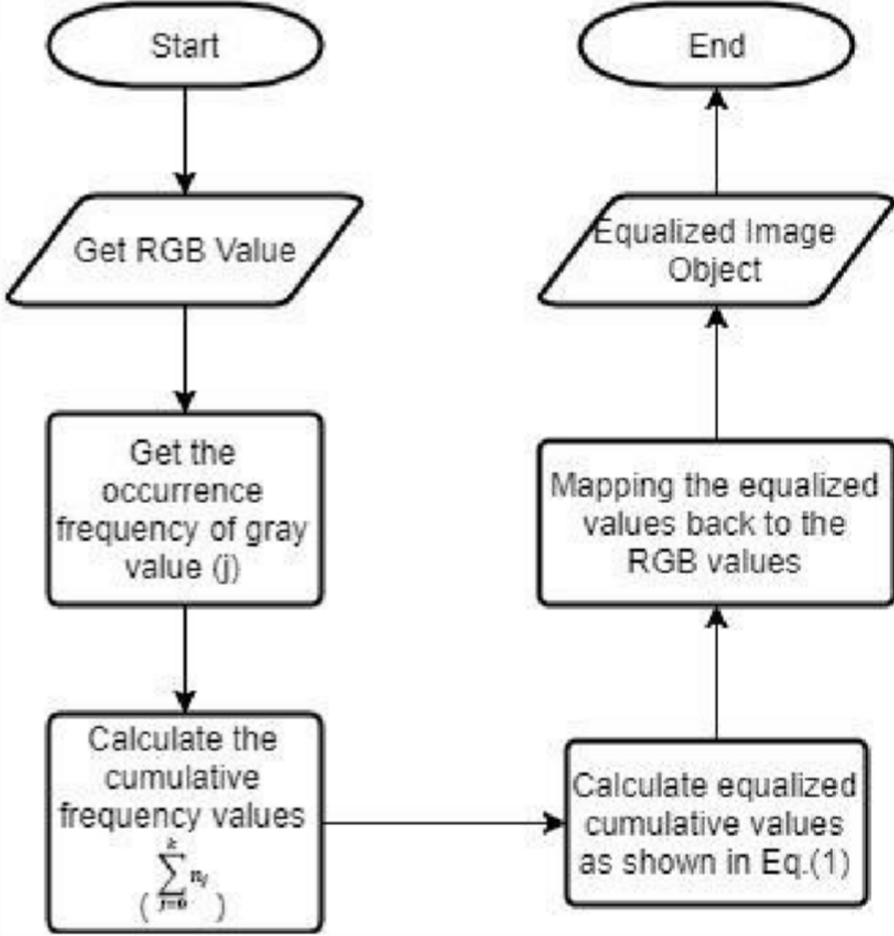

Proposed Work and Methodology Adopted

### What This Work Seeks to Achieve:

The main aim of this paper is to rectify the general problems that are associated with the standard histogram equalization. Regular techniques process the entire image in the same way, i.e., it increases contrast by the same factor to all areas irrespective of whether they were originally dark or light. This leads to overly processed or dull results, and therefore the image will be either too extreme or not yet enhanced enough.

To prevent that, a more adaptive and region-dependent approach has been devised. It's a hybrid procedure that treats a combination of various intelligent methods step by step to improve contrast without degrading the original appearance of the image and preserving the crucial details.

### Here's how it works:

1. Eliminate the Noise First

Before you get to boosting anything, the image is first cleaned up in order to cut down on any unwanted noise—particularly handy with low-light pictures or noisy-sensor pictures. Techniques such as median filtering or Gaussian smoothing are applied to remove this random visual detritus. The plan is to eliminate the trash without blurring essential features such as edges, so subsequent steps aim to boost the correct things.

1. Break the Image into Small Pieces

Rather than treating the entire image as a whole, it breaks the image down into small blocks. Each block is treated separately. It does allow for areas that are too dark or too light to be treated individually according to their own individual needs. It tends to preserve the details evenly throughout the image—even in difficult lighting conditions— without ruining the overall appearance.

1. Use CLAHE for Smarter Local Contrast

Then, CLAHE, or Contrast-Limited Adaptive Histogram Equalization, is run on each of these smaller areas. CLAHE is wonderful because it enhances local contrast without overdoing it. It does this by controlling how much contrast augmentation is done, so

minor changes aren't amplified beyond reason. This preserves textures and fine details as being nice and crisp and realistic, which is particularly beneficial in fields such as medical imaging or reading number plates.

1. Enhance the Details with Edge-Preserving Filters

Finally, the image is run through an edge-preserving filter, such as a bilateral filter or guided filter. These filters will remove any final minor noise or glitches but, unlike classical blurring operations, will not blur important edges or details. The end result is a clean image with crisp outlines and readable text. Why This Matters: By performing all of these steps simultaneously, this process precludes the usual pitfalls of standard histogram equalization. You get an even-balanced image that's less tiring to look at, shows more information, and transitions more smoothly to changing illumination in the scene—all without sacrificing the natural appearance or structural definition.

## Results and Discussion

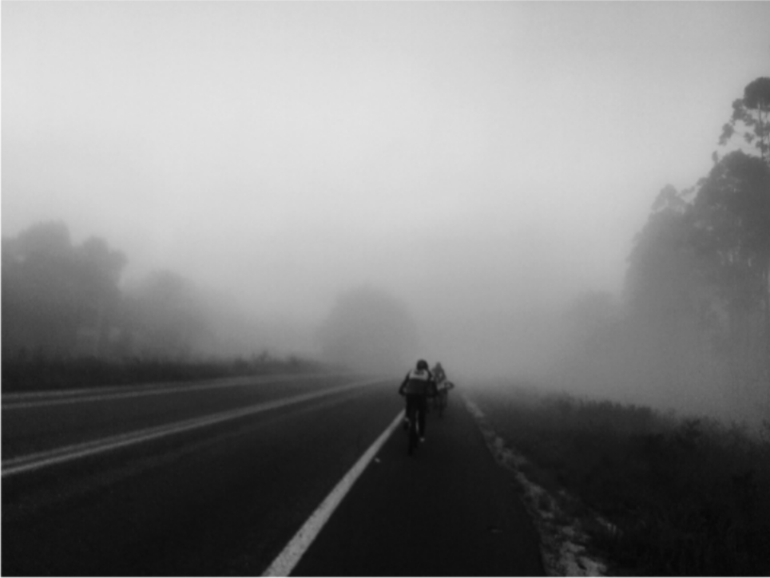

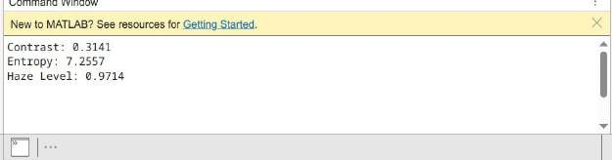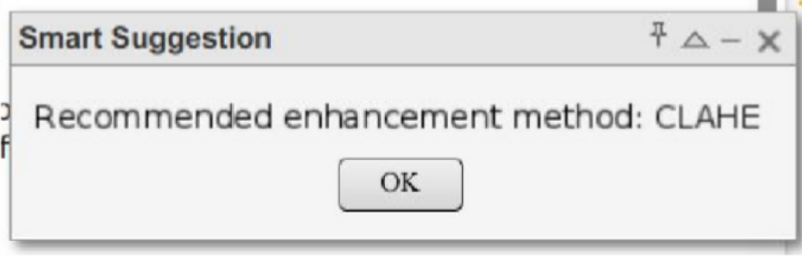

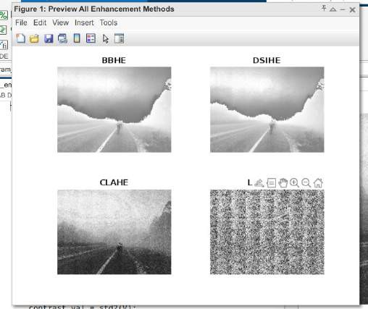

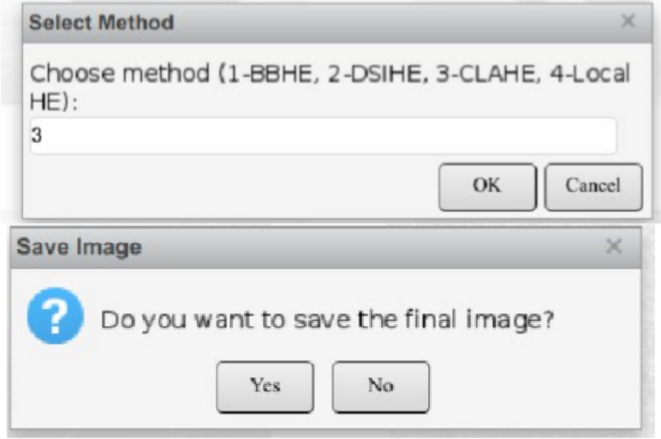

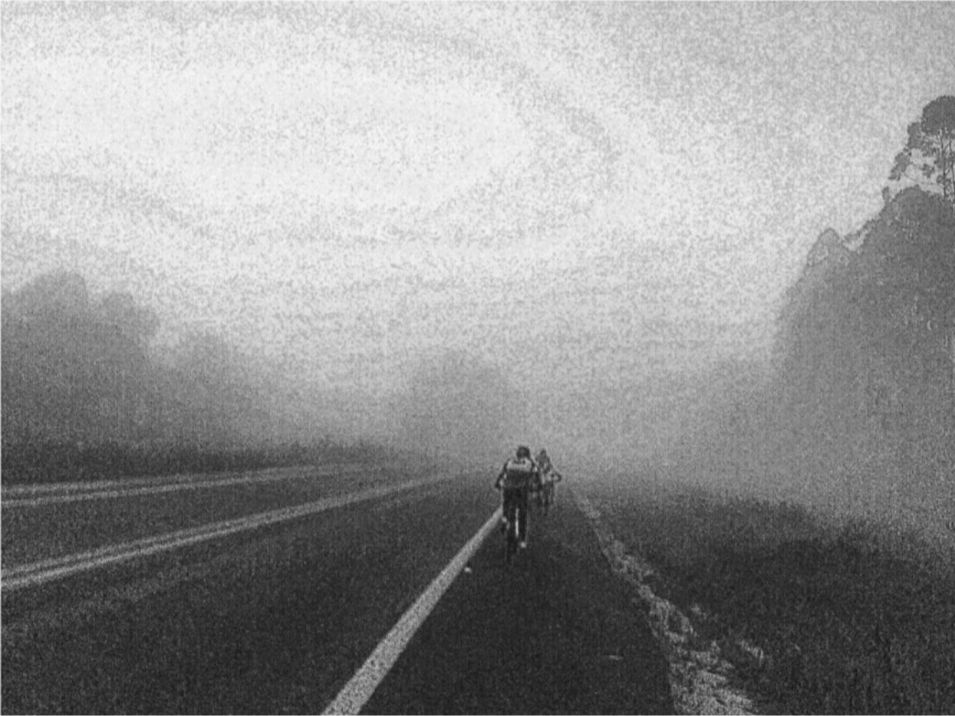

Conclusion

Histogram equalization is a significant and widely used digital image enhancement technique. It is applied due to its simplicity, speed, and efficiency in contrast enhancement and detail disclosure. This paper has explained how it works, its disadvantages, and the manner in which it is applied in various real-world applications such as medical imaging, satellite imaging, security images, and photography.

After considering both the old and new methods in depth, it's clear that the basic version of histogram equalization works well most of the time, but it also has some problems. It can, sometimes, change brightness, add noise, or overbrighten some parts of the image— especially in areas of little change. These problems mean that we need more powerful, more flexible solutions.

And that's where the improved technique provided here comes into play. With the application of localized techniques like CLAHE, combined with initial noise reduction and edge-preserving filters subsequent to enhancement, this technique manages to deliver images that not only are more uniformly balanced but also clearer and more detailed. It provides contrast where it's needed without exaggeration or muddying essential details— therefore more appropriate for images taken in challenging light or with irregular brightness.

With greater, region-adaptive techniques making histogram equalization better, the technique is transformed into an increasingly powerful tool in contemporary image processing. This study demonstrates how a vintage technique may evolve with clever updates to cater to current necessities, paving the way for superior and hybridized solutions in the future.

## Future Scope of Work

While the methodology developed in this work is surely an improvement upon traditional histogram equalization, as a field of study, image enhancement is being rapidly advanced now—especially following the emergence of smart, learn-based technologies. In the next few years, there is ample potential to engage machine learning as well as deep learning to impart intelligence and an ability to sensitively respond to the actual contents of individual pictures to image improvement.

One such interesting area is the use of deep neural networks, specifically Generative Adversarial Networks (GANs). Such networks can be trained on large sets of images to transform low-quality images into high-quality images. GANs, with the understanding of parameters such as lighting, noise, and structure, can generate outputs that are more natural-looking and illustrate how human subjects perceive image quality.

Another idea that works well is combining old techniques with new techniques for representing meaning. For instance, if we could identify significant regions in an image— such as faces, road signs, or certain regions in medical images—we could make those regions more visible without altering the rest. Using methods such as semantic segmentation or object detection, we could enhance visibility in significant regions while leaving the rest of the image unchanged. This would render the improvement more helpful and less distracting.

There is a growing need to utilize smart techniques in real-time on low-power hardware, such as smartphones, embedded systems, or edge devices found in autonomous cars and security systems. The future research can concentrate on optimizing these algorithms so that they operate quickly and efficiently without the need for high-power hardware.

In short, the future of image improvement is the meeting of the simplicity of classical methods and the intelligence of today's data-driven systems. By uniting these two worlds, we can create smarter, faster, and more agile solutions that perform well on all types of real-world tasks.

## REFERENCES

1. R. Gonzalez and R. Woods, *Digital Image Processing*, 4th ed., Pearson, 2018.
2. N. Abdullah, A. Tajuddin, and A. Jalil, “Brightness Preserving Histogram Equalization for Image Enhancement,” *Int. J. Electr. Comput. Eng.*, vol. 5, no. 5, pp. 1050–1056, 2015.
3. B. Z. Azam, “Wavelet Based Histogram Equalization,” *J. Vis. Commun. Image Represent.*, vol. 20, no. 5, pp. 332–341, 2016.
4. M. Sharma and S. Kaur, “Adaptive Histogram Equalization Using Fuzzy Filtering,”

*Signal & Image Processing*, vol. 6, no. 2, pp. 71–82, 2015.

1. T. Celik and T. Tjahjadi, “Contextual and Variance-Based Contrast Enhancement,”

*IEEE Trans. Image Process.*, vol. 20, no. 12, pp. 3431–3441, 2011.

1. S. S. Bedi and R. Khandelwal, “Various Image Enhancement Techniques: A Critical Review,” *Int. J. Adv. Res. Comput. Commun. Eng.*, vol. 2, no. 3, pp. 1605–1609, 2013.
2. M. Abdullah-Al-Wadud, Md. H. Kabir, M. A. Dewan, and Oksam Chae, “A Dynamic Histogram Equalization for Image Contrast Enhancement,” *IEEE Transactions on Consumer Electronics*, vol. 53, no. 2, pp. 593–600, 2007.
3. Z. Rahman, D. J. Jobson, and G. A. Woodell, “Retinex Processing for Automatic Image Enhancement,” *Journal of Electronic Imaging*, vol. 13, no. 1, pp. 100–110, 2004.
4. Y. Kim, “Contrast Enhancement Using Brightness Preserving Bi-Histogram Equalization,” *IEEE Transactions on Consumer Electronics*, vol. 43, no. 1, pp. 1–8, 1997.
5. R. C. Gonzalez and R. E. Woods, *Digital Image Processing Using MATLAB*, 3rd ed., Gatesmark Publishing, 2009.
6. Pizer, S. M., et al., “Adaptive Histogram Equalization and Its Variations,” *Computer Vision, Graphics, and Image Processing*, vol. 39, no. 3, pp. 355–368, 1987.
7. Arici, T., Dikbas, S., and Altunbasak, Y., “A Histogram Modification Framework and Its Application for Image Contrast Enhancement,” *IEEE Transactions on Image Processing*, vol. 18, no. 9, pp. 1921–1935, 2009.
8. Wang, Z., Bovik, A. C., Sheikh, H. R., and Simoncelli, E. P., “Image Quality Assessment: From Error Visibility to Structural Similarity,” *IEEE Transactions on Image Processing*, vol. 13, no. 4, pp. 600–612, 2004.
9. Kaur, M., and Kaur, J., “Survey of Contrast Enhancement Techniques Based on Histogram Equalization,” *International Journal of Advanced Research in Computer Science and Software Engineering*, vol. 4, no. 4, pp. 822–825, 2014.
10. H. Demirel and G. Anbarjafari, “Image Resolution Enhancement by Using Discrete and Stationary Wavelet Decomposition,” *IEEE Transactions on Image Processing*, vol. 20, no. 5, pp. 1458–1460, 2011.